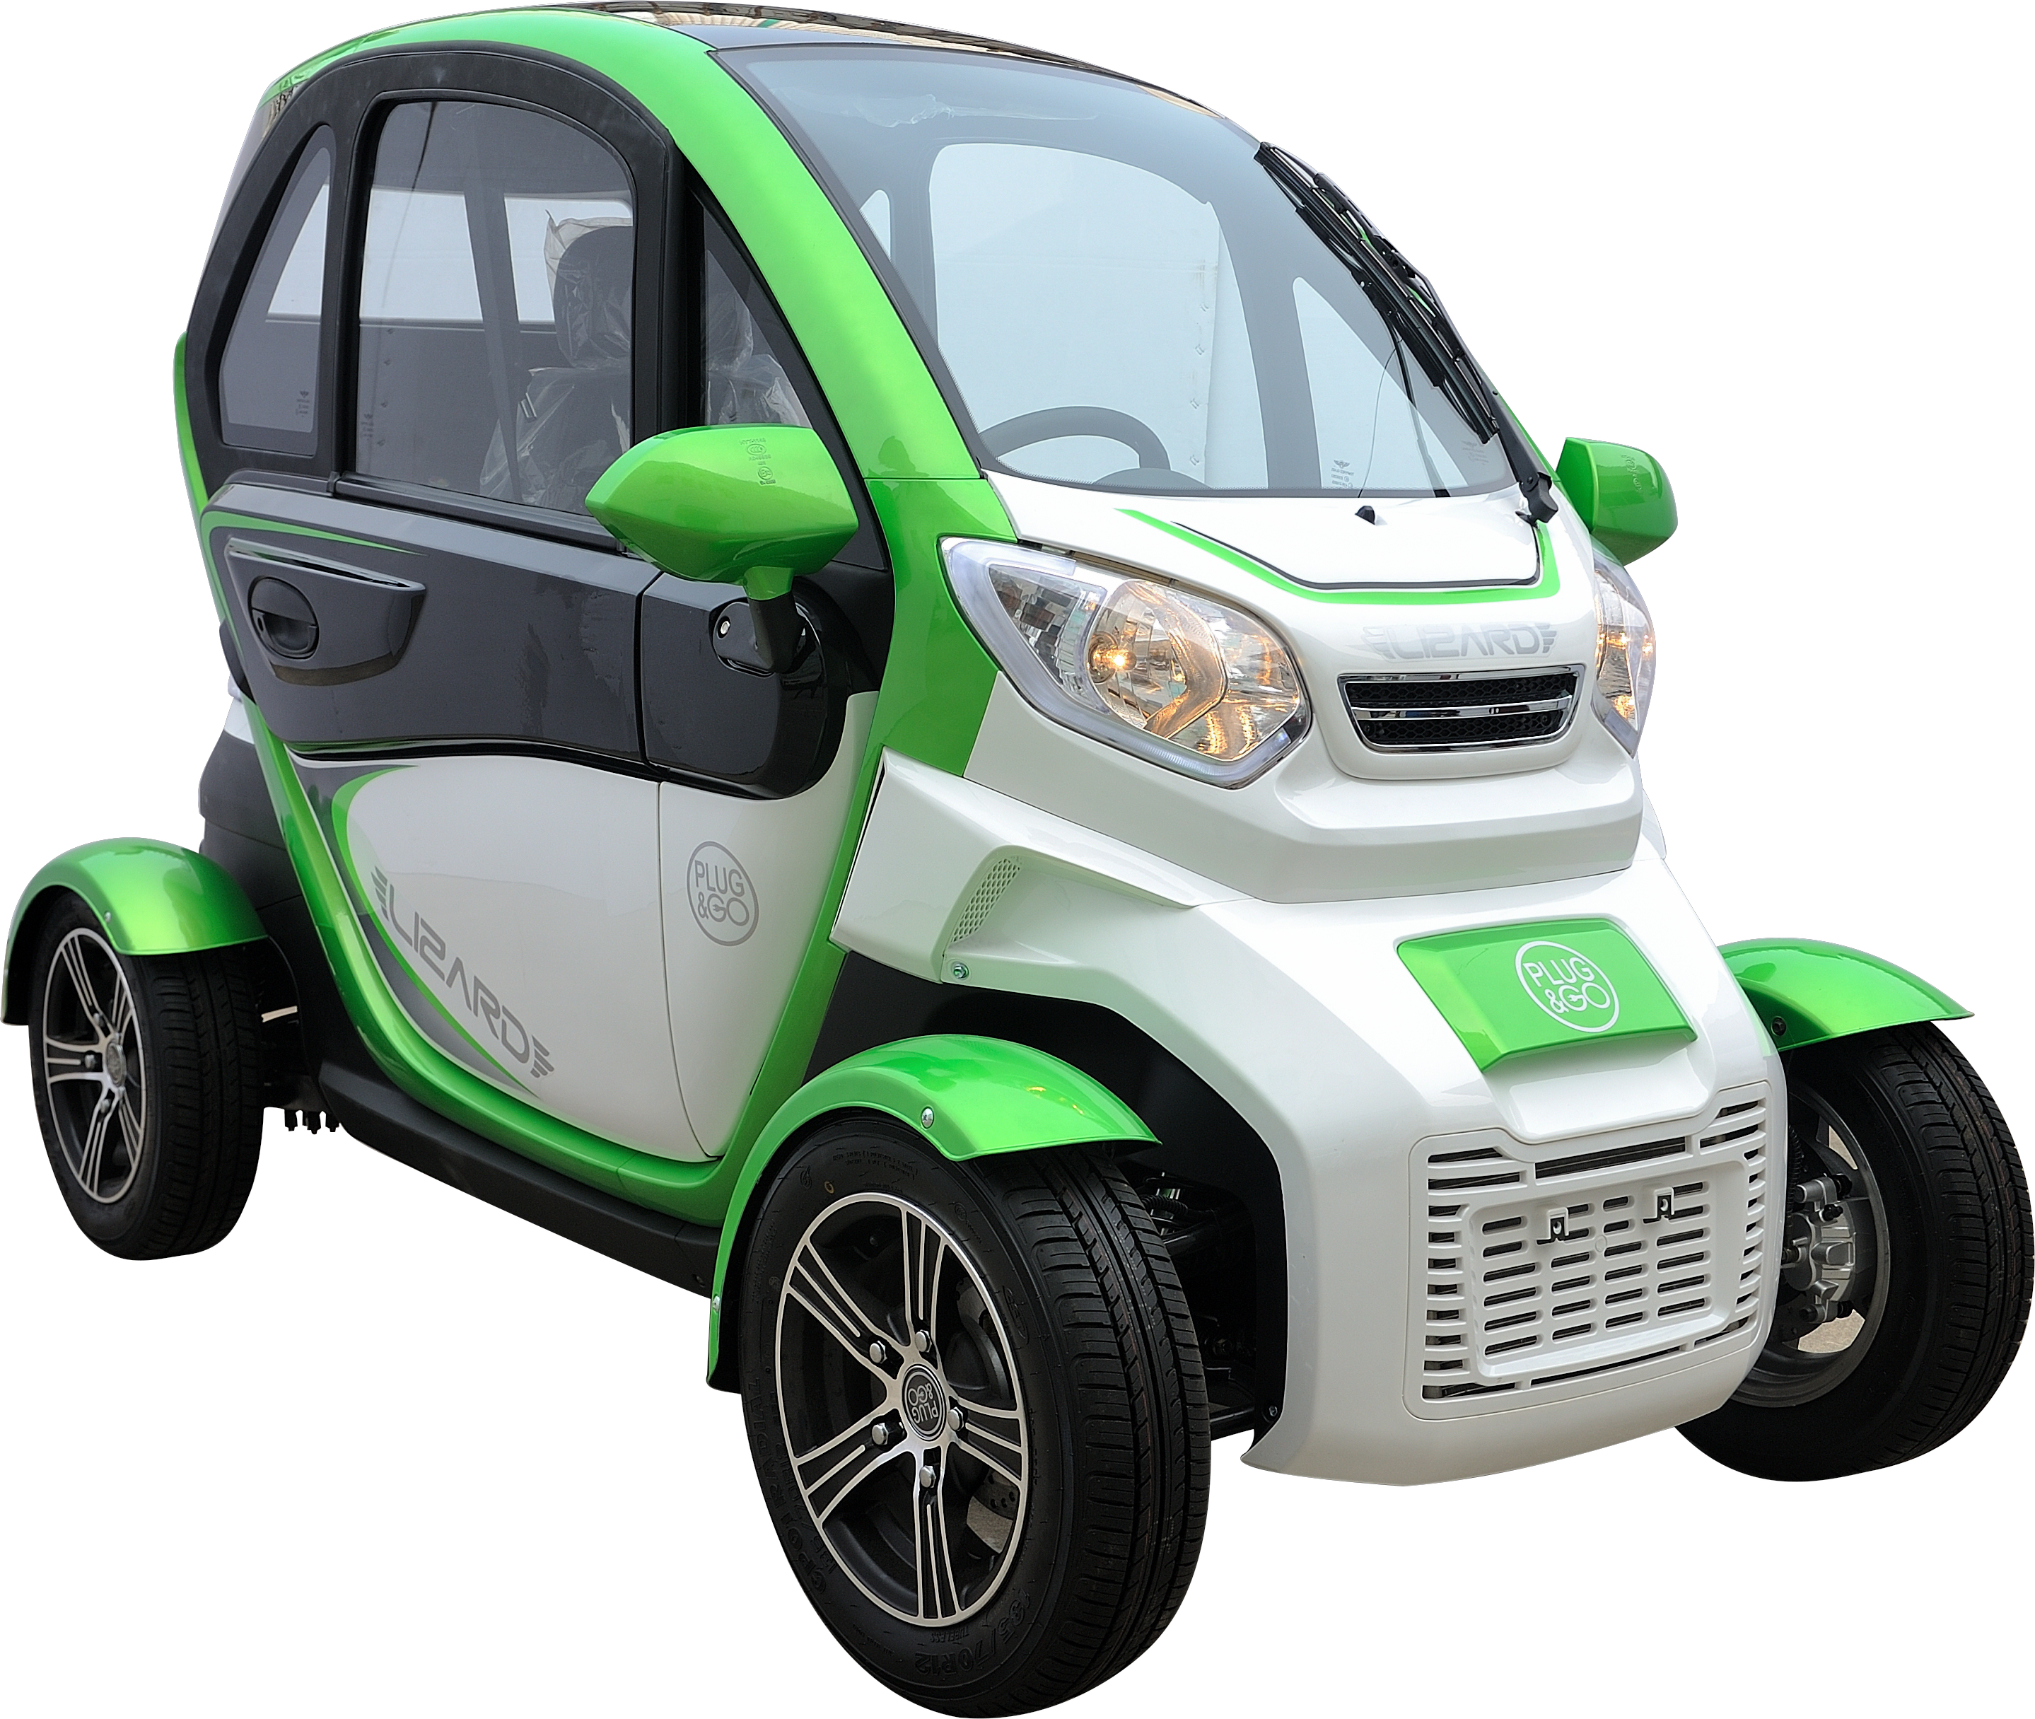

Introduction
Thank you for purchasing Anaig Quick electric vehicle, and sincerely welcome to join the ranks of driving Anaig electric vehicle. In order to have a safer and more enjoyable driving effect, please read this manual carefully before your first use, and familiarize yourself with the vehicle structure, features, instructions and relevant regulations of our company as soon as possible. The contents in this manual will help you to master the correct method of driving and maintaining the vehicle so that you can fully enjoy driving pleasure.
An inspection should be done firstly before driving every time, and regular maintenance is the most basic condition. If you need regular maintenance or repairs, remember that only our local company's special maintenance department knows best what to do, and it also ensures the best operational performance. If you own a variety of mechanical knowledge and maintenance tools, the special dealerships can provide the parts catalog and authentic parts to help you do all kinds of maintenance and repair.
This manual describes the correct operation, simple maintenance and adjustment methods and essentials of Quick electric vehicle for durable use. If some technical specifications of the vehicle are changed, some pictures or contents in this manual may differ from the actual situation, please understand. We reserve the right of final interpretation.
Do not modify the vehicle in any way. Otherwise, it may adversely affect the safety, durability and performance of the vehicle and violate the limited warranty conditions.
We wish you a pleasant drive and thank you for choosing the Anaig electric vehicle again.

Attention

• Driver and Passenger
This electric vehicle is designed for one driver and one passenger (Not allowed to carry children under the age of 12 alone). Never exceed the load of this vehicle specified in the manual.
• Road Conditions
This electric vehicle is limited to driving on flat roads.
• If some technical specifications of the vehicle are changed, some pictures or contents in this manual may differ from the actual situation, please understand. We reserve the right of final interpretation.
• Please read this manual carefully
Pay special attention to any sentence or paragraph marked with the following warning symbols.
Warning, caution, notice, and certain special symbols will frequently appear in this manual. Please pay attention to these information that may indicate a hazard that could result in injury or damage to your vehicle.

"Warning" means that if you do not follow the instructions it will likely cause a serious injury or death;
"Caution" means that dangerous or unsafe operations will cause injuries or damages to the vehicle;
"Notice" indicates that drivers and passengers should avoid the operation that could endanger the vehicle or personal safety.

This manual should be regarded as a permanent part of this electric vehicle. Even when the vehicle is transferred to another person, it should be handed over to the new owner.

When purchasing a vehicle, the owner should receive instruction from a professional in Anaig special dealerships to learn about driving, charging, and daily maintenance of the electric vehicle. If there are any problems during using, please contact Anaig special dealerships in time.

1、The electric parts of Anaig electric vehicle are components where water is strictly prohibited, especially the controller. The owner must pay attention when cleaning the vehicle.
2、The vehicle should speed up slowly when it starts. Stepping on the accelerator pedal lightly is both safe and power-saving, allowing us to drive comfortably.
3、Charge when the power indicator reaches the minimum two compartments (or the voltmeter indicated in the yellow indication)! Otherwise, the battery will be over-discharged, at which point the battery's damage will be irreparable.
4、Users are not allowed to install electric components or modify other normal components on their own. The loss caused by this will be borne by users.
5、In the cold weather, the battery's activity will decrease and the mileage will be shorter than that in summer. This is a normal phenomenon.
6、Vehicle charging plug cannot be touched by hand, otherwise the voltage above 72V is enough to cause harm to the human body.
7、The vehicle is equipped with a high-voltage power battery, and the operating voltage of the drive motor is also high voltage. All high-voltage cables and plugs have been designed, manufactured, and assembled in accordance with relevant national and industry standards. Except as allowed in this manual, do not touch the high-voltage cable (the color of this cable is orange) and the connector to prevent electric shock.
8、Please follow all warning labels attached to the vehicle parts.
9、Any changes to the vehicle parts may affect the vehicle performance and high-voltage safety, resulting in safety hazards such as electric shock. Therefore, any work involved in disassembling electrical systems or replacing relays must be carried out by Anaig special dealerships. Do not disassemble or replace by yourself!
10、Recommendations for the use of vehicles in extreme weather:
In summer, the weather is hot and high in temperature. To ensure the safety of vehicles and drivers, do not park the vehicle in the sun for a long time. It is best to park in an open space with good ventilation. In rainy days, if the water on the ground is above the bottom of the battery pack, do not start the vehicle, please contact the Anaig special dealership in time. In winter, the efficiency of the power battery is low, After your use, please charge the vehicle immediately to improve the charging efficiency.
11、Attentions in the accident:
· Turn the shift knob to "N" and turn off the ignition switch.
· If wires in the car are exposed or damaged, do not touch any wires to prevent electric shock.
· If there is a fire, immediately leave the vehicle and put out the fire with an ammonium phosphate extinguisher or plenty of water.
· If the collision occurs, do not restart the vehicle.
· When the vehicle is partially or completely submerged in water, turn off the ignition switch and escape in time. If there is no bubble or sizzle sounds, the salvage operation can be performed. If bubbles or sizzle sounds are found, wait until they disappear. At this time, there is no risk of electric shock by touching the vehicle body or structure whether in water or on shore.
12、Power battery system recovery:
The power battery used in this vehicle is a lead-acid battery, installed in the lower part of the vehicle body. Random disposal may cause pollution and harm to the environment. For details on the disposal of the lead-acid battery, please consult Anaig special dealerships.

Contents

1.Safe Driving
1.1.Safe Driving Regulation……….……1
1.2.Load…………………………………….…2
2.Position Chart and Instructions of
Components
2.1 Vehicle Schematic 1………………3
Vehicle Schematic 2…………..
2.2 Instrument Panel Schematic ……….5
2.3 Instrument and Indicator Lamp……….6
2.4 Ignition Switch………………………7
2.5 Lights and Signal Control Switch Lever..
2.6 Wiper Switch Lever
2.7 Multimedia Player ………………..8
2.8 Rearview Mirror……………………….…9
2.9 Main Power Control Switch……………10
2.10 Mechanical Door Locks………….…11
2.11 Remote Controller of Door Lock(Optional)……….
2.12 Adjustable Seat………………….12
2.13 Power Windows and Control Button..12
2.14 Keyless Starter (Optional)…...…...13
2.15Heating System (Optional)……..……14
2.16 A/C System (Optional)…...…………14
2.17 Reading Lamps ……...…...…...16
2.18. Warning System of Security.…17
2.19 Charging System………..18
2.20. Power Battery Pack………20
3.Starting and Driving
3.1 Attentions ……………..…...………22
3.2 Stopping..………………………
3.3 Parking
3.4 Gear Shifter……….…
3.5 Braking System……….………………
3.6 Economical Speed..…………………
3.7 Tire…………………….…………
4 Maintenance and Repair
4.1 Regular Maintenance Projects..…..…
4.2 Maintenance……………………..…
4.3 Troubleshooting…………….…
5. Vehicle Storage……………………..…35
6. Vehicle Identification Number(VIN)……36
7. Technical Data………………………………37
8. Electrical Schematic…………………….39.

1.Safe Driving

This chapter mainly introduces the important information, operating instructions, recommendations and attentions for a safe driving. For the safety of you and passengers, please read carefully and observe the relevant regulations.
A. While driving a vehicle, please comply with local regulations on driving qualifications. If the driving license is required, only the person who gets the license or has studied and trained can drive it. If you drive this vehicle for the first time, please be supervised by trained technician to avoid accidents.
B. Do not drive the vehicle with the rearview mirror folded.
C. Adjust the seat to a right position before driving. Make sure that you and other occupants wear safety belts properly before starting the vehicle.
D. Drive with caution. Pay attention to the traffic, roads and weather conditions, and keep enough distance from the vehicle ahead. Avoid driving at night with dazzling lights, blind spots and unprepared conditions.
E. When you are driving, pay attention to other vehicles and pedestrians. When changing lanes, please observe the rearview mirror and use the turn signal in advance. Do not drive when you are tired.
F. Do not use mobile phones while driving. When the vehicle is in an emergency parking, press the switch to turn on the hazard warning lamp.
G. Please drive slowly in rainy days. The wading depth should not exceed the ground clearance, otherwise it will cause the motor fault.
H. Overspeed or overload is easy to cause accidents, so please comply with state regulations and never try a dangerous driving.
I. Your ability to respond to environment changes will decrease after drinking. The more you drink, the slower your reaction. So, do not let you or your friends drive after drinking.
J. Do not get too close to other vehicles while driving. Please comply with the local traffic regulations.

Capacity of Loading: Only 150 kg (two people). If the vehicle is overloaded, its stability and operation will be affected.

Position Chart and Instructions of Components
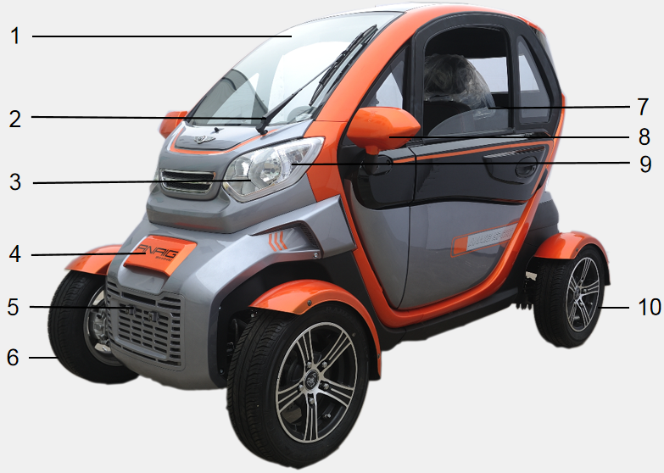
2.1) Vehicle Schematic 1

1、Windshield 2、Wiper 3、Headlight 4、Hood 5、Front License Plate 6、Front Wheel 7、Power Window 8.Rearview Mirror 9.Turn Signal Light 10.Rear Wheel

Vehicle Schematic 2
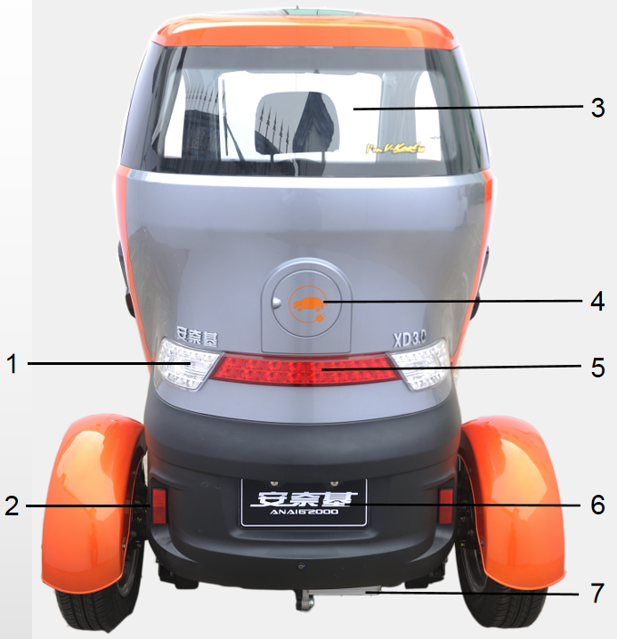

1、Taillight and Turn Light 2.Reflector 3.Rear Window 4、Charging Port 5. Braking Light 6、Rear License Plate 7、Motor

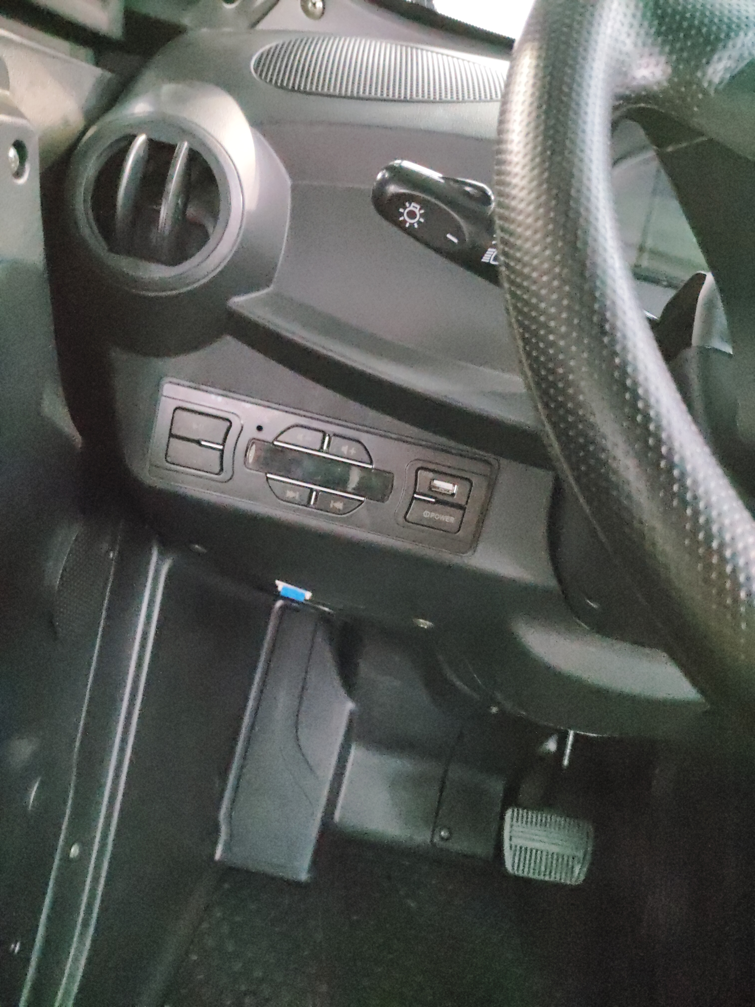
2.2) Instrument Panel Schematic A
1、Headlight and Turn Light Switch
2、Left Air Outlet
6
3、Media Player
4、Accelerator Pedal
5、Brake Pedal
6、Instrument Assembly
7. Main Power Control Switch

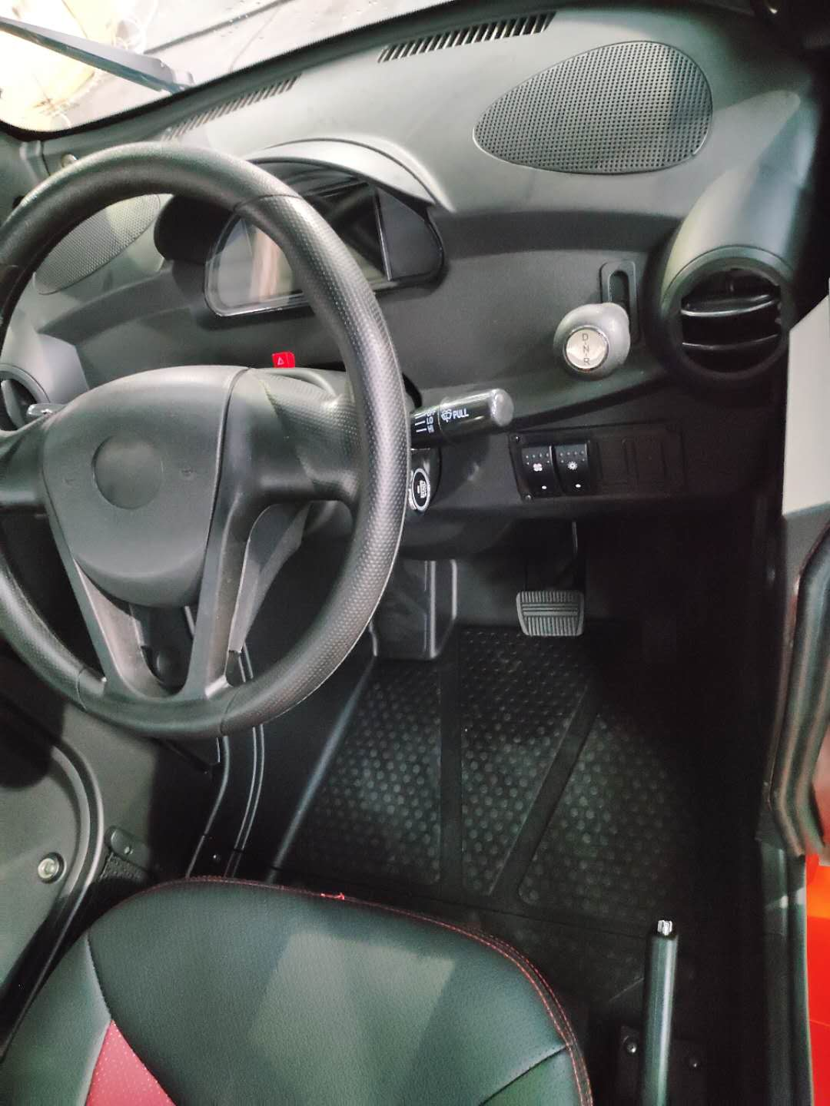
Instrument Panel Schematic B
4
1、Right Air Outlet 2、Shift Knob
1
3
3、Wiper Switch 4、Speaker
2
5、Parking Brake 6、Natural Wind Switch
7
6
7、Heating Switch 8、Ignition Switch
8
9、Steering Wheel 10、Horn Button
9
10
5

2.3) Instrument and Indicator Lamps
(1) Left and Right Turn Indicator lamps:
After the turn signal button is toggled, the left or right turn indicator lamp will be flashing.
(2) High-beam Indicator Lamp:
While the switch is in the "" position, the high-beam indicator lamp will be on.
(3) Gear Indicator Light:
In the case the gear is in the different position of "Drive", " Neutral" or " Reverse" , the indicator lamp shows "D", "N" and "R" respectively.
(4) Position Indicator Lamp:
While the headlight switch is in the "" position, the position indicator lamp will be on.
(5) Power Volt Meter:
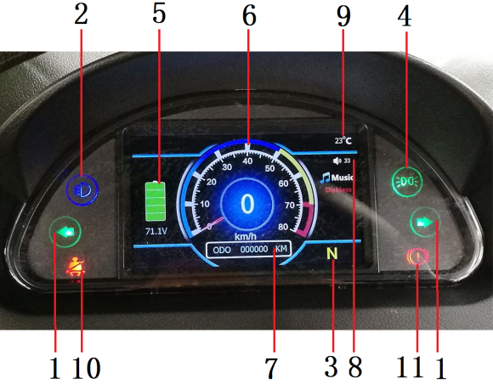
After the ignition switch is turned on, the remained capacity of battery power is shown.
(6) Speedometer:
Display the speed of the vehicle while driving.
(7) Odometer:
Record the mileage of the vehicle.
(8) Multimedia Volume:
Display the current multimedia volume.
(9) Ambient Temperature:
Display the current ambient temperature.
(10) Front Seatbelt Indicator Lamp:
Display the status of the front seatbelt.
(11) Parking Indicator Lamp:
Display the parking status of the vehicle.
2.4) Ignition Switch
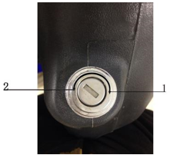
On: Turn the key to position 1, the vehicle circuit is connected. Then the vehicle can start and all electrical components can work normally, but the key cannot be pulled out in this situation.
Off: Turn the key to position 2, the vehicle circuit is disconnected. The vehicle cannot start and all electrical components stop working, then the key can be pulled out.
2.5) Lights and Signal Control Switch Pole
(A) Headlight and Turn Signal Light Switch
OFF: All lights are off;
:Turn on Position Lights, Taillights, License Plate Light and instrument panel lamps.
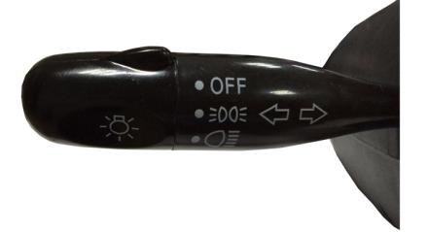
: Turn on Headlights, Position Lights, Taillights, License Plate light and instrument panel lamps.
If the vehicle is not on driving, do not turn the headlights and other lights on for too long time. Otherwise it will waste battery power and cause excessive battery discharge.
When it is rainy or the vehicle washed, the lens of headlights may be fogged.In this case, it is not a problem, which is the same as the fog on the glass in wet days. and it will be disappeared by the heat of the lamp when it is lighted up.
Turn/Lane-Change Signals:
When the turn light switch is turned on, the turn lights and its indicator lamp will be flashing.
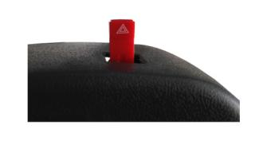
(B) Warning Switch
Pull out this switch when you have to park in an emergency. At this point, all turn signal lights will be flashing. When the warning switch is turned on, the turn signals will not work properly.

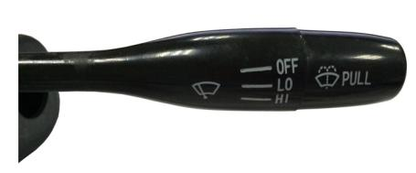
2.6) Wiper Switch Lever
(A) There are three gears of Wiper at Wiper Switch: OFF-LO-HI
OFF: Turn Wiper off.
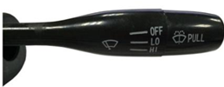
LO: Wiper works at normal speed.
HI: Wiper works at high speed .

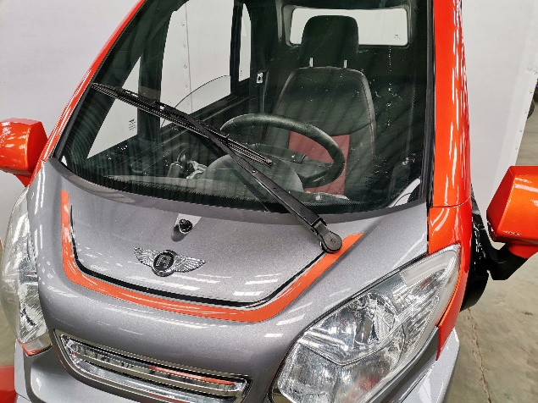

(B) A single circle of windshield cleaning: Pull the lever of the windshield wiper up to spray cleaning fluid and activate the wipers. The wiper keeps working till the lever has been released.

(C) How to refill Cleaning Fluid!

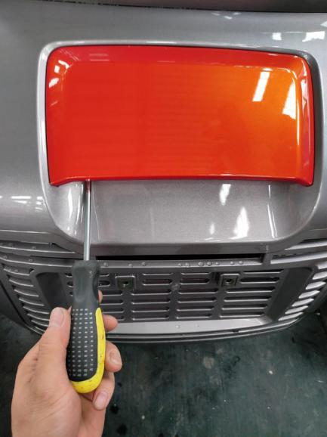
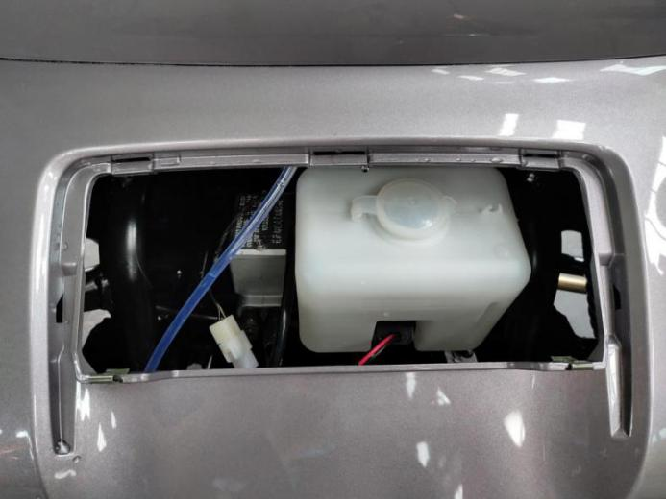

a) Open the cover. b) Refill the cleaning fluid tank.

2.7) Multi-media Player

(A) Turn On/Off
The default is the radio status when the power is on for the first time.
On: Press the power button to turn on the player.
Off: Hold down the power button to turn off the player.
(B) Mode Switching
When the player is turned on, press the "MODE" button to switch between "Radio \ USB" mode.
(C) Volume Adjustment
Press the "+" button to increase the volume and press the "-" button to decrease the volume.
(D) Playback Control
Press the "" button to play and pause the music;
Press the "" button to play the next music;
Press the "" button to play the previous music.

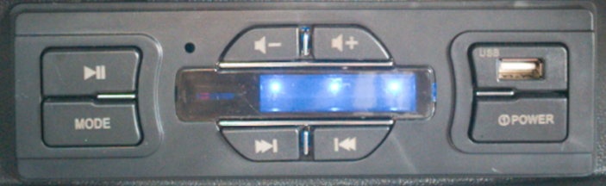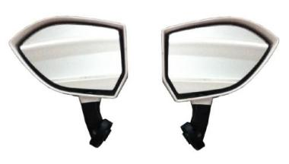

2.8) Rearview Mirror
The rearview mirrors can be manually adjusted. Be sure to sit in the cab and manually adjust the rearview mirrors to the most suitable position before your first drive. Under special road conditions, the rearview mirrors can be folded inward.
Fold the mirror inward when there is a special road condition.
2.9) Main Power Control Switch
The power control switch is located under the multimedia player on the left side of the cab.
When the power control switch is in the up (ON) state, it means that the power is turned on and this vehicle can be operated.
When the power control switch is in the down (OFF) state, it means that the power is turned off and this vehicle cannot be operated.

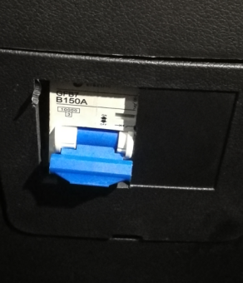

2.10) Mechanical Door Lock and Key
A、Use the key 1 to unlock the door and then open the door with the handle 2.
B、Door Lock: turn the key counterclockwise to lock the door and clockwise to unlock the door.
2.11) Remote Controller of Door Lock (optional)
A、Press the button 1 to unlock the door and then you can open the door from the outside.
B、Press the button 2 to lock the door and then the door cannot be opened from the outside.

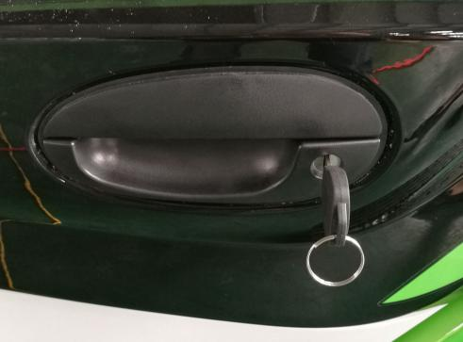
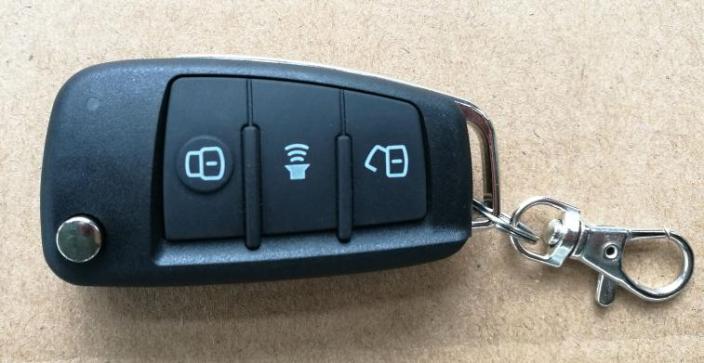
2
1
1
2

2.12) Adjustable Seats
A、Lift the handle 1 to slide the seat back and forth to the desired position, then release the handle.
B、Lift the lever 2 to recline the seat back to the desired position, then release the lever to lock the seat back in place.

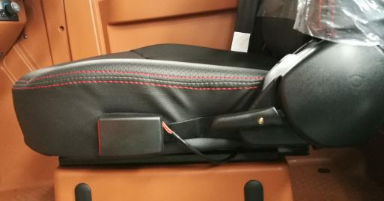
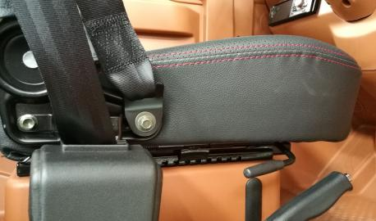
1
2

2.13) Power Windows and Control Button
Raise the window glass: Pull Button 1. Then Power Window will be closed, as shown Fig.1.
Pull Down the window glass: Press Button 1. Then Power Window will be opened, as shown Fig.2.
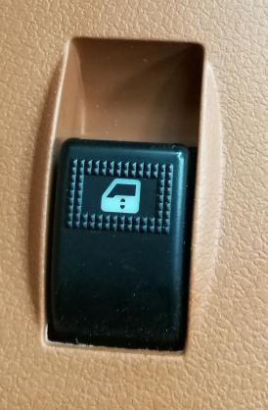
1

1

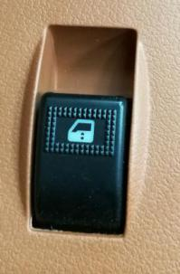

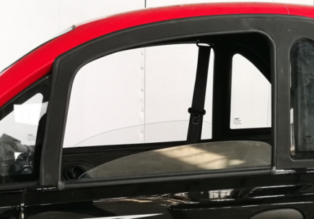

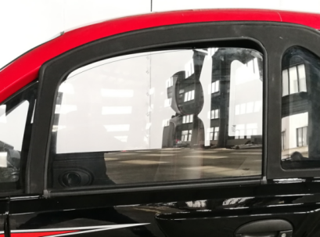

Fig. 1. Raise the window glass

Fig. 2. Pull down the window glass

Warning:
If you do not use the lift button as specified, it may cause injury!
·When you leave the vehicle (including a temporary leave), remember to pull out the ignition key. Never leave a child alone in the vehicle.
·Do not be careless while closing the windows. Otherwise, it may cause serious harm to yourself or others! Therefore, make sure there is no person in the moving window area
·Make sure that no one in the vehicle when you lock the door form the outside, because it is impossible to open the window from the inside in an emergency!

2.14) Keyless Starter (optional)
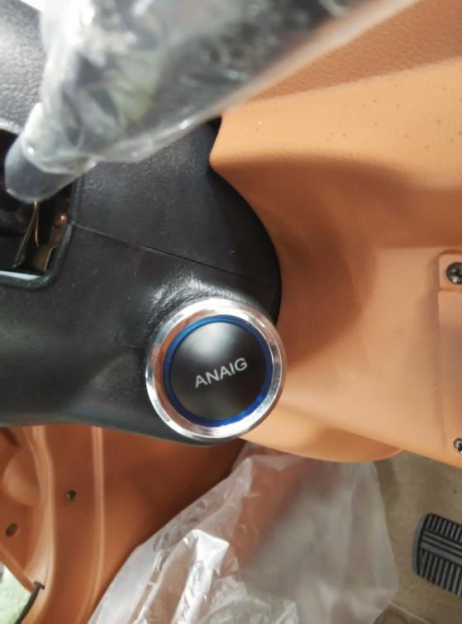
This function requires the remote keyless entry transmitter.
After the transmitter unlocks the vehicle, step on the brake pedal and press the engine-start-stop button until the instrument is turned on, then you can operate the vehicle. If you need to turn off the power, please park the vehicle safely first. Then step on the brake pedal and press the engine-start-stop button.
When the engine-start-stop turns on the power, the remote keyless entry transmitter is temporarily invalid.
2.15) Heating System (optional)
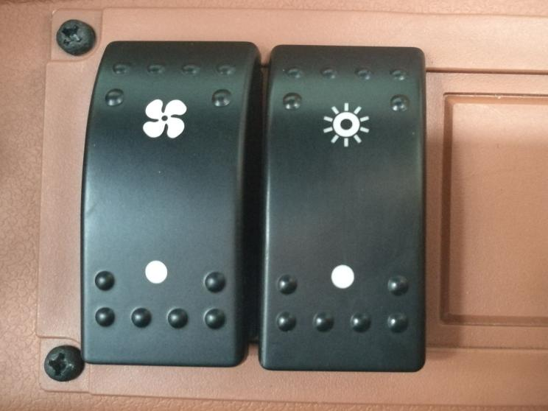
A、To open the natural wind system and inhale fresh air, press the upper part of the button 1. To close the natural wind system, press the bottom of the button 1.
2
1
B、To open the heating system, press the upper part of the button 2, then system will deliver warm air. To close the heating system, press the bottom of the button 2.

2.16) A/C System (optional)
1.Air Conditioning and Fan Control:
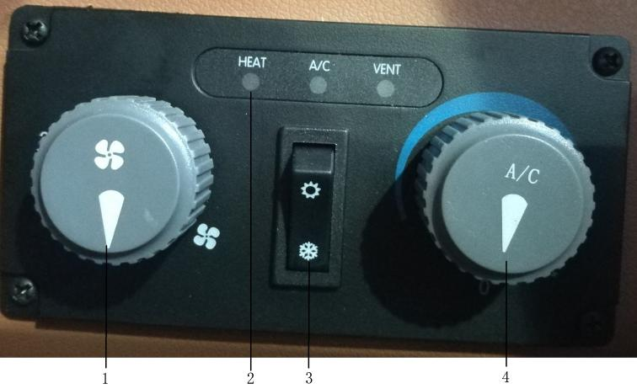
Turn the knob 4 clockwise or counterclockwise to turn on or turn off the air conditioning. To increase the fan speed, turn the knob 1 clockwise. Conversely, turn counterclockwise.
2. A/C Status Indication:
HEAT for heating air;
A/C for cooling air;
VENT for natural wind.
3. A/C Mode:
❄ for cooling; ☀ for heating.
4. A/C Knob:
Turning the knob 4 clockwise can adjust the temperature for cooling.
Warning:
· Unclear windows can easily increase the risk of accidents and casualties. For safety reasons, all windows must be free of ice, snow and fog to ensure a clear view.
·If the air in the vehicle is turbid, it can easily make the driver fatigued and distracted, thus causing accidents and casualties.
·The diagnosis and maintenance of air conditioning systems require the expertise and specialized tools. Thus, please go to the Anaig special dealership for repair when the air conditioning system breaks down.

Notice:
·When the outside temperature and humidity are high, the moisture in the air will condense on the evaporator of the refrigeration system to form water droplets. They will drip from the evaporator and cause water to accumulate under the vehicle, which is a normal phenomenon.
·Keep the air inlet in front of the windshield free from obstruction, so as to ensure normal heating and cooling, and prevent the windshield from fogging.
·The air conditioning system will work better when the windows (or the sunroof) is closed. However, if the vehicle is hot after exposed to the sun, please open the windows and let the heat dissipate first, which can speed up the interior cooling.

Turning on the air conditioning can reduce the temperature and humidity inside the vehicle, but it is only available when the ignition switch is in the "ON" position and the vehicle is in the "READY" state.
The air conditioning compressor will consume energy during the cooling process. Thus, in order to minimize the operating time of the A/C system, please pay attention to the following:

If the vehicle is hot after exposed to the sun, open the windows and doors to let the heat dissipate first.
·If you use the A/C system while driving, please close all windows to maximize the efficiency.
·The air conditioning can start working only when the fan is turned on. If the ambient temperature is close to 0℃, the air conditioning cannot cool the vehicle. If neither the cooling button nor the heating button is pressed, the air conditioning only has the ventilation function.
·The operation of the A/C system will increase the extra power consumption. There is an indication of the remaining power in the instrument, from which you can judge the influence of air conditioning on the vehicle mileage. When the battery power is low, it is recommended to reduce the use of the air conditioning to maximize the vehicle mileage.
·To defrost or defog the windshield as soon as possible, it is recommended to turn on the heating mode when defrosting is required, and to turn on the cooling mode when defogging is required. If the ambient temperature is low, the heating mode can be used for defogging.
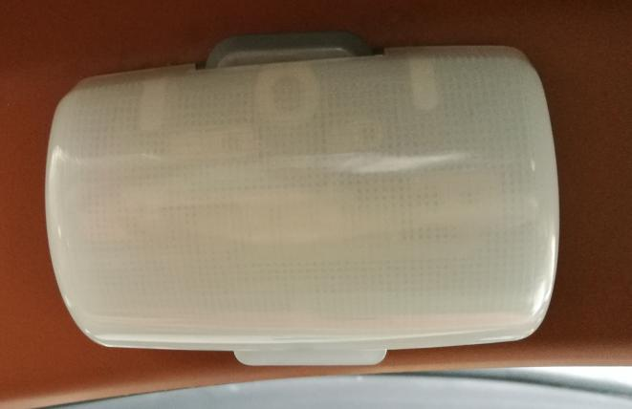
·If the air humidity is high, there may be a slight fog on the windows when the A/C system is turned on. This is a normal phenomenon and it will disappear after a few seconds.
1

2.17) Reading Lamps (optional)
The reading lamp is located on the right side of the roof. It is off when the switch is in the middle position. To turn on the lamp, press the switch to the left or right.
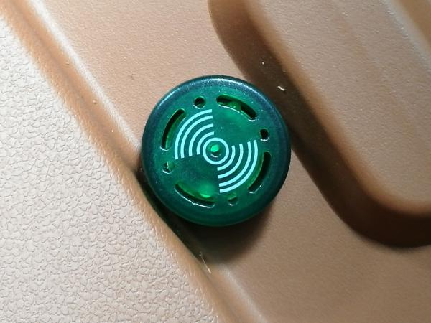
2.18). Warning System of Security
Buzzer is located inside the left and right doors. It is hooting while:
A、Reversing;
B、One or more of the doors is unlocked;
C、Leaving the vehicle without turning off the ignition switch.
Warning:
In the case the buzzer keeps hooting for a long time, please to confirm whether the vehicle is in any of the above states. Only after the buzzer stops hooting/whistle, can you start driving.

2.19) Charging System

Warning:
The vehicle charging system has high voltage. Unauthorized modification of vehicle charging system components and charging equipments or touching damaged components may result in electric shock and death. After an accident, do not touch any components marked with a high-voltage warning sign or modify vehicle parts marked with that sign. You should go to the Anaig authorized dealerships to conduct an electrical safety inspection of the accident vehicle.

Connecting the charging cable to the power supply via an adapter, extension cable, or similar equipment while the vehicle is charging may result in a fire or electric shock, posing a risk of fatal injury. For safety reasons, please use only the charging cables and charging equipment provided by the vehicle or specified by the manufacturer. Do not use a damaged charging cable. When you find that the charging cable or the power supply is abnormally hot, stop charging and check the charging products at the Anaig authorized dealerships.
Caution:
During the charging process or at the end of charging, please pay attention to the following safety precautions to protect yourself and others.
• Please choose to charge in a relatively safe environment (avoid liquid, fire sources, etc.).
• When encountering weather conditions such as heavy rain, lightning, blizzard, hail, etc., do not touch the charging port to avoid personal injury caused by electric shock.
• After charging, do not disconnect the charging connection device with wet hands or standing in water to avoid personal injury caused by electric shock.
• After charging, disconnect the vehicle from the charging device in the manner specified in the manual to avoid product damage or performance degradation due to the improper operation.
• During or after charging, make sure the vehicle is in the N gear before disconnecting the charging connection device.
• The normal working environment temperature of the charging system is 0 ℃ ~ 50 ℃. The charging efficiency will be significantly reduced at the too low or too high temperatures, and the charging time will be longer than that at the normal temperatures. Do not charge the lithium battery at an ambient temperature below 0 ℃.

• It is recommended to park the vehicle in a ventilated place during charging.
• The self-discharge phenomenon of the power battery system may occur during the parking period. It is recommended to carry out AC charging at least once every 15 days for battery balancing and maintenance to improve the battery life.
• The available energy of the power battery system will decrease slightly over time.
• Do not park for more than 7 days when the state of charge (SOC) of the power battery is too low (about 10% to 20% SOC).
• Please go to the designated or professional maintenance department to repair the charging part or replace the charging fuse. Do not operate without permission.
• For repairing or replacing batteries and electrical components, turn off the main power switch before operation.
• Do not allow children to touch the charging pile.
- Charging procedure using the household AC power supply (taking European standard charging gun as an example):
a. Open the the protective cover of the vehicle charging socket above the taillight, twist the inner dust cover fully counterclockwise, and then pull out the inner dust cover.
b. Pay attention to the plugs on the charging cable. The large end of the 7-hole charging gun should insert into the charging port on the vehicle, and the two-pole plug should insert into the household power socket.
Caution:
The charger can work normally only when the household power supply has a ground

connection.
c. Pay attention to the charging gun in place to ensure a reliable connection. Then turn on the power and start charging the electric vehicle.
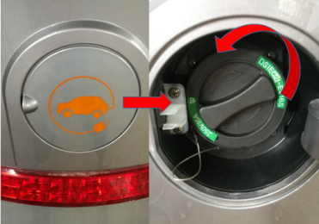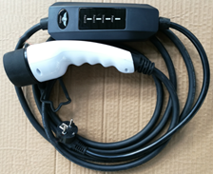
Vehicle End
Socket End
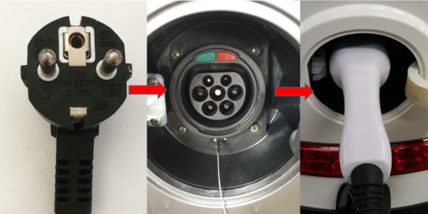
d. During the charging, the indicator light on the charging controller will display the vehicle charging status. From top to bottom, the indicator lights are the power indicator light, the charging status indicator light and the charging system fault indicator light. When the two-pole plug is connected to the power supply, the power indicator light in Figure 1 will light up; when the charging gun charges the vehicle battery, the status indicator light in Figure 2 flashes, and the status indicator will be on when the charging is completed. If the charging system is in fault, the fault

indicator light in Figure 3 will flash.
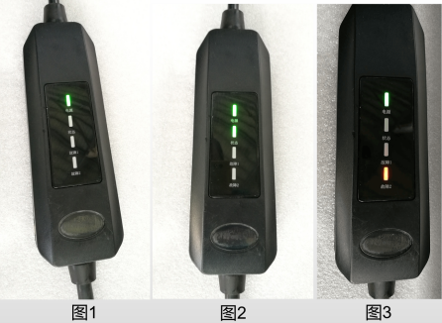
Figure 1 Figure 2 Figure 3
e. After the charging is completed, the user needs to wait for the status indicator to light up, and first unplug the charging gun at the vehicle end, then unplug the charging plug from the household power socket.
f. Cover the dust cover of the charging gun on the vehicle and close the charging cover. Then put the charging device into the special storage box.
- Charging procedure using the public AC power charging pile (taking American standard charging gun as an example):
Caution:
Before using the public charging pile, please make sure that the public charging pile provides AC power charging service with a voltage of 220 V.
If the vehicle battery is the lead-acid battery, please select the 16 A charging range for charging.
If the vehicle battery is the lithium battery, please select the 32 A charging range for charging.
B1. Charging procedure using a public AC power charging pile equipped with a charging gun:
a. Open the protective cover of the vehicle charging socket above the taillight, press the switch on the inner dust cover to open the inner dust cover.
b. Insert the charging gun into the vehicle charging port directly. Please pay attention to the charging gun in place to ensure a reliable connection. Then turn on the power and start charging the electric vehicle.
c. When the control display on the charging pile indicates that charging has been completed, unplug the charging gun and then hang it back to the public charging pile. Close the dust cover of the charging port and the protective cover of the vehicle charging socket.
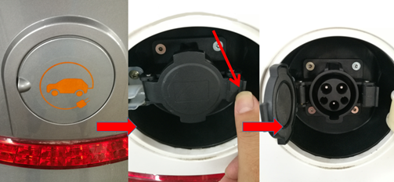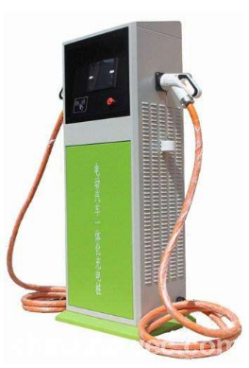
Press
B2. Charging procedure using a public AC power charging pile without a charging gun:
a. Open the protective cover of the vehicle charging socket above the taillight, press the switch

on the inner dust cover to open the inner dust cover.
b. Insert one plug of the self-provided charging gun (Figure 1) into the charging socket of the public charging pile (Figure 2), and then plug the other end of the charging gun into the vehicle charging port. Pay attention to the charging gun in place to ensure a reliable connection. Then turn on the power and start charging the electric vehicle.
c. When the control display on the charging pile (Figure 2) indicates that charging has been completed, first unplug the charging gun at the vehicle end, and then unplug the charging plug connected with the charging pile. Close the dust cover of the charging port and the protective cover of the vehicle charging socket. Then put the charging device into the special storage box.
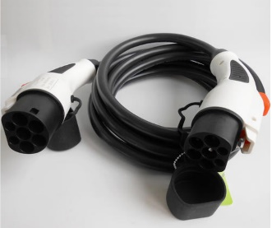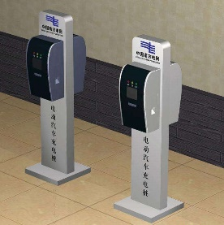
Press the switch
Figure 1 Figure 2

2.19) Power Battery Pack
1. Lead-acid battery
Lead-acid batteries are designed to be maintenance-free, so solutions cannot be added. Under the normal charge and discharge conditions, the cycle life of lead-acid batteries is about 300 times;

(1) Use and maintenance of lead-acid battery
• If the vehicle is used for the first time or after being parked for a long time, there may be deviations in the state of charge (SOC) displayed by the instrument, so it is recommended to fully charge the vehicle before using.
• Always remove the dust and dirt from the battery cover and keep the battery dry and clean to prevent the battery from self-discharging.
• Never leave the battery in a state of insufficient power for a long time. The good habit of charging the battery every night should be developed, and the battery should be recharged every time the 40% -50% power is used. If the battery is not used for a long time, the battery should be fully charged, placed in a cool and dry place, and recharged regularly (usually once every 15 days).
• When the vehicle is running, pay attention not to allow the battery to over-discharge. Generally, the battery should be charged best when the battery is discharged at a depth of 50% -60%. When the power indicator has only two divisions on, charge the battery as soon as possible to prevent the battery from over-discharging.
• The discharged battery should be recharged in time and should not be left for more than 12 hours.
• Avoid overcharging, please stop charging when the charger shows full.
• Avoid long-term power loss, otherwise it will vulcanize the polar plates. It is best to run out of the battery power once a month, that is, drive the vehicle until the battery is under-voltage and discharged deeply, and then charge the battery, which can extend the battery life.
- Do not expose the battery to sunlight, otherwise the temperature of the battery and the activity of various active materials in the battery will be increased and the service life of the battery will be

affected.
(2) Disconnection and removal of lead-acid battery
• Before disconnecting or removing the battery, make sure that the ignition switch and other electrical components are turned off.
• First disconnect the negative ("-") connection, then disconnect the positive ("+") connection.
• When reconnecting, connect the positive lead first and then the negative lead.
• Loosen the limit bolts that fix the battery pressure plate and take out the battery pressure plate. Use the lifting handle (if installed) to lift the battery from the vehicle.
Warning:
• Do not turn the battery's electrodes upside down. If the battery's electrodes are reversed, the electrical system may be damaged.
• Do not short the positive terminal and negative terminal of the battery under any circumstances to avoid serious safety accidents such as burns and injuries.
• Always keep the battery upright. If the battery is tilted more than 40 °, it may cause damage or even a safety accident.
• After the vehicle is started normally, do not disconnect the battery during parking and driving.
• Do not allow battery terminals or leads to come into contact with tools or metal parts on the vehicle.
• Do not disassemble and modify the battery.
(3) Replacement of lead-acid batteries(少了铅酸电池照片)
Only the batteries of the same type and conforming to the original specifications shall be assembled. Other batteries may not be the same in size or the terminal positions may be different, which may cause battery damage, leakage or fire.
Make sure the battery is installed correctly when replacing. Ensure that the battery tray and pressure plate are securely fixed to prevent the battery from moving during an accident or emergency stop.
• The following figure is the wiring diagram of the 60 V dual battery.

3,Starting and Driving
3.1)、Starting Attentions
A、To ensure that the charging socket is disconnected.
B、Move the shift lever to N (Neutral) .
C、Turn on the ignition switch and ensure that all indicators and signal lamps are normal.
3.1.1)、Strting Procedure
A、Turn the ignition key to START and check the instrument.
B、Move the shift lever to the corresponding gear.
C、Release the parking brake and step on the accelerator pedal lightly.
Warning:
To ensure that your foot is off the accelerator pedal while starting. When the engine starts, step on the accelerator pedal slowly to avoid adverse consequences.
Caution:
·Do not place your hand on the shift button (or shift lever) while driving.
·Make sure that the shift lever is in N(Neutral) position before starting.
3.2)、Stopping
Please follow the procedure：

A、Be sure of Shift Lever at N (Neutral) position, pull up the parking brake ,and turn off ignition switch, then confirm the power of the car has been cut off.
B、Do not put the ignition key in ON position to avoid battery discharging. Also, be sure to pull out the key and get it with you.
3.3、Parking

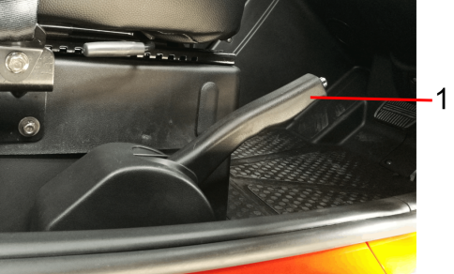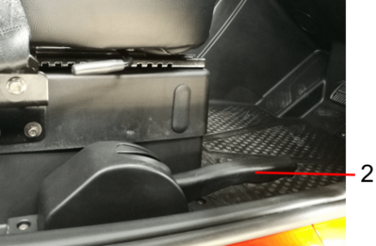

a、Pull up the parking brake lever and do not press the lever button at this time.
b、Be sure to completely release the parking brake lever before driving. The specific method is to hold the lever button and release the parking lever downward.
Warning:
Driving with the parking brake on can overheat the brake parts and the motor, which will affect the braking performance and increase the wear of the brake. In severe cases, the motor may burn out.
Warning:
Try to tighten the brake lever when parking, especially on the slope.
3.4、Gear Shifter
To drive the vehicle forward, move the shift lever to D (Drive). To drive the vehicle backward, move the shift lever to R (Reverse). It should be noted that in order to ensure the service life of the motor, the controller has already done the corresponding protection. Only when the vehicle is parked, can you move the lever to D (Drive) or R (Reverse).
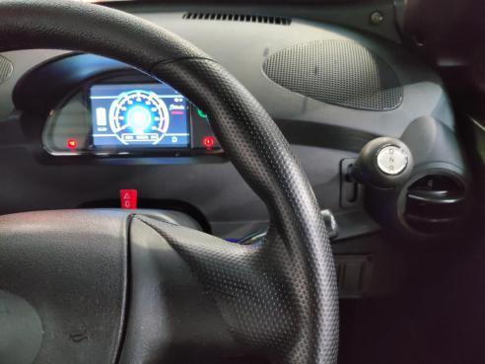
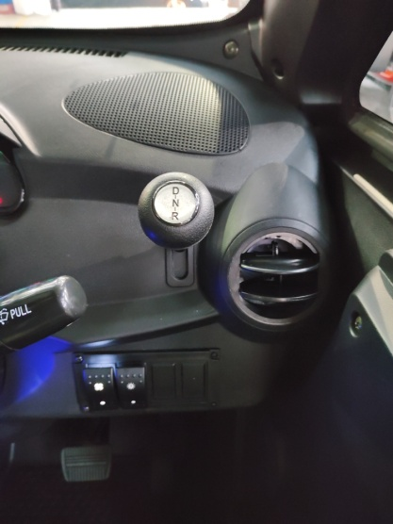
A、When the shift button(or shift lever) is in N position, the drive motor is activated.

B、Please step on Brake Pedal while starting the drive motor.
C、Do not allow the drive motor to run at high speed while the vehicle is stopped and the shift lever is in D (Drive) or R (Reverse).
D、Do not release the parking brake before the vehicle restarts. Remember that once the gear is selected, the vehicle will move forward or backward slowly.
E、Do not keep the vehicle stationary after the shift lever is in D (Drive) or R (Reverse) and the drive motor has been running. If the vehicle needs to be stationary for a long time, please select N (Neutral).
F、You can move the shift lever from D (Drive) or R (Reverse) to N (Neutral) directly.
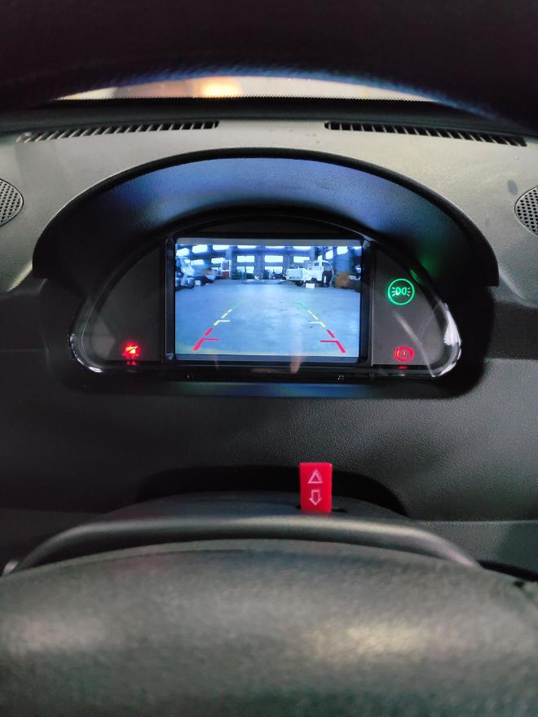
G. Back View at the gear of Reverse

3.5)、Braking System
a、The four wheels are equipped with brakes. If you put your foot on the brake pedal while driving, the brake will operate slightly and generate heat, which reduces the braking effect, shortens the service life of the brake lining and increases the energy consumption. Also, the fact that the brake lamp is always on will cause the rear driver to misjudge the situation. After the vehicle passes deep water, the brake must be checked. Step on the brake pedal appropriately to feel whether the braking effect is normal, if not, please step on the padel frequently until the braking effect returns to normal.
b、The brake pad requires a run-in period. In the first 800 km, the sudden brake should be avoided as much as possible. Remember to have a regular maintenance, it ensures that brake system parts are inspected for wear at appropriate intervals and replaced as needed to get the safety and the optimal performance for a long time.
3.6)、Economical Speed
It is recommended that the vehicle should drive at an economical speed of 30-35 km/h to ensure the longest mileage. The driver can adjust the speed according to the vehicle condition and the load.
3.7)、Tire (Tire Pressure: 250kPa)
Please check and adjust the tire pressure regularly.
A、To check the tire pressure only when the tire is in cooled condition.
B、To check whether there is a puncture on the tire. If the tire is leaking, please repair it immediately.
C、To check whether there are any cuts, nails or other sharp objects on the tire surface and whether there is any indentation or deformation on the hub.
D、Tires should be replaced when tire tread is worn to the tire wear indicator.
Warning:
If the tire pressure is not up to the standard, the tire surface will suffer too much wear and may cause accidents. The too low tire pressure will cause the tire to slip out of the hub.
Warning:
To use tires heavily worn is dangerous, which will affect the adhesion between tires and the road surface and cause driving difficulties or even accidents.
4. Maintenance and Repair
Regular Maintenance Project: Please go to the special service station of the Anaig electric vehicle for the maintenance as required.
No. | Item | Detail Information | Interval mileage (km)
 |  |  | 3000 | 7000 | 12000 | 17000 | 22000 | 27000 | 32000 | 37000 | 42000
1 | General Electrical Apparatus | Vehicle lighting, warning lamp, horn: Check performance. | ● | ● | ● | ● | ● | ● | ● | ● | ●
 |  | Wiper, wiper blade, cleaning device: Check performance. | ● | ● | ● | ● | ● | ● | ● | ● | ●
2 | Power  Battery | Check three power plugs of the power supply system to find whether there is any external damage, whether the connection is fastened. | ● | ● | ● | ● | ● | ● | ● | ● | ●
 |  | Check the appearance of the power supply system to find whether there is any external damage, cracks or serious deformation which may damage the internal single core and electrical parts. | ● | ● | ● | ● | ● | ● | ● | ● | ●
3 | DC-DC Converter | Measure whether the DC-DC converter output voltage is in the normal range. | ● | ● | ● | ● | ● | ● | ● | ● | ●
 |  | Check the wire harness in the DC-DC converter: Whether the corrugated pipe surface is aged and cracked, the connector is loose, and the harness terminal bolts are loose. | ● | ● | ● | ● | ● | ● | ● | ● | ●

No. | Item | Detail Information | Interval mileage (km)
 |  |  | 3000 | 7000 | 12000 | 17000 | 22000 | 27000 | 32000 | 37000 | 42000
4 | Charger | Check whether the charging socket is loose, and whether there is an ablation phenomenon. To confirm whether the connection is fastened, insert and pull out the charging gun once at least. | ● | ● | ● | ● | ● | ● | ● | ● | ●
 |  | The charger's AC input harness, DC output harness and power plug should have a good appearance and be free of bad phenomenon such as defects, cracks and deformation. | ● | ● | ● | ● | ● | ● | ● | ● | ●
5 | Motor  Controller | Check the fixing bolt torque of the motor controller B+, B- terminals and the motor three-phase line (U/V/W). | ● | ● | ● | ● | ● | ● | ● | ● | ●
6 | Air conditioning | The compressor's input harness and connectors should have a good appearance and be free of bad phenomenon such as defects, cracks, deformation and ablation. | ● | ● | ● | ● | ● | ● | ● | ● | ●
 |  | The PTC input and connectors should have a good appearance and be free of bad phenomenon such as defects, cracks, deformation and ablation. | ● | ● | ● | ● | ● | ● | ● | ● | ●
 |  | Check if the functions of air volume adjustment, blow mode and internal and external circulation switching are normal. | ● | ● | ● | ● | ● | ● | ● | ● | ●

No. | Item | Detail Information | Interval mileage (km)
 |  |  | 3000 | 7000 | 12000 | 17000 | 22000 | 27000 | 32000 | 37000 | 42000
7 | Steering and  Steering Force | Steering drive shaft dust cover: Check for damage | ○ | ○ | ○ | ○ | ● | ● | ● | ● | ●
 |  | Steering tie-rod head: Check the clearance and whether the dust cover is damaged. | ○ | ○ | ○ | ○ | ● | ● | ● | ● | ●
 |  | Steering tie-rod dust cover: Check for damage or dislocation. | ○ | ○ | ○ | ○ | ● | ● | ● | ● | ●
8 | Door and Safety Belt | Door hinge and door check: Lubricate. | ○ | ○ | ○ | ○ | ● | ● | ● | ● | ●
 |  | Safety belt: Check for stuck or non-return phenomenon. | ○ |  | ○ | ○ | ● | ● | ● | ● | ●
9 | Brake and Braking Force | Brake, brake fluid reservoir: Visually check for leak, damage and brake fluid level. | ● | ● | ● | ● | ● | ● | ● | ● | ●
 |  | Parking brake: Check its travel and adjust if necessary. | ● | ● | ● | ● | ● | ● | ● | ● | ●
 |  | Brake pipe: Check whether there is any damage, corrosion and leak at all joints. | ● | ● | ● | ● | ● | ● | ● | ● | ●
 |  | Brake disc, brake pad: Check its thickness. | ● | ● | ● | ● | ● | ● | ● | ● | ●
10 | Ball Stud  and  Rubber Sleeve | Ball stud: Check the clearance. | ○ | ○ | ○ | ○ | ● | ● | ● | ● | ●
 |  | Suspension rubber sleeve: Check whether it is damaged. | ○ | ○ | ○ | ○ | ● | ● | ● | ● | ●

No. | Item | Detail Information | Interval mileage (km)
 |  |  | 3000 | 7000 | 12000 | 17000 | 22000 | 27000 | 32000 | 37000 | 42000
11 | Toe | Toe, camber angle: Check, adjust if necessary. | ● | ● | ● | ● | ● | ● | ● | ● | ●
12 | Drive Shaft | Check if there is an oil leakage and the rubber sleeve is damaged | ● | ● | ● | ● | ● | ● | ● | ● | ●
13 | Tire | Adjust the tire pressure, check the wheel bolt torque. | ● | ● | ● | ● | ● | ● | ● | ● | ●
14 | Bolt | Check the torque of connecting bolts on the chassis and between the power supply system and the body. | ● | ● | ● | ● | ● | ● | ● | ● | ●
15 | Bearing | Front and rear wheel bearings: Check their clearance and lubrication. | ○ | ○ | ● | ○ | ● | ○ | ● | ○ | ●
16 | Rear Axle  Reducer | Replace the gear oil in the rear axle reducer. | ● | ○ | ● | ○ | ○ | ○ | ● | ○ | ○
Note: 1、● Need inspection ○No inspection if there is no special circumstance
2、After the first and second maintenance, regular maintenance should be carried out every 5000km.
3、The balance of the power battery voltage shall be inspected at each regular maintenance. After the first maintenance, the gear oil of the reducer should be replaced every 1 year or 30,000 kilometers.
Gear oil type: Summer API GL-4 SAE 85W-90; Winter API GL-4 SAE 75W-90.
The brake fluid must be replaced every 2 years or 50,000 kilometers. If you use the vehicle in a particularly bad condition, replace the brake fluid every 1 year or 25,000 kilometers.

Maintenance
The maintenance cycle is based on the mileage of the vehicle and it is the guiding basis for the regular maintenance and lubrication of the vehicle. If the vehicle drives at high speed for a long time under harsh conditions, you must increase the number of maintenance. If the vehicle has been overhauled or collided, it is necessary to ask the maintenance department personnel to carefully check the main parts and repair or replace the misplaced or damaged parts for safe driving.
Method
◆When mileage is up to 3,000 km for the first time, the rear axle reducer needs to change the gear oil, and then replace it according to the mileage interval in the above table.
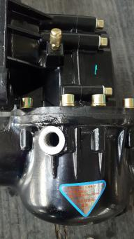
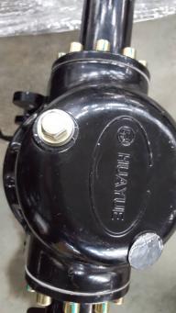
◆Open the bolt 1 to discharge the gear oil, then tighten the bolt 1. Open the bolt 2 to pour in gear oil (85W/90GL-4) approximately 650ml, then tighten the bolt 2 after refueling.
1
2

Caution:
To ensure the safety and reliability, do not modify the electric vehicles. Please use new original parts or equivalent parts of the same quality when repairing or maintaining. If you use other poor-quality parts, it will the performance and operation of electric vehicles.
When the glass spray kettle is short of water, add water to the kettle regularly.
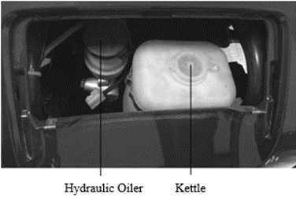
Warning:
To ensure the safety of personnel, regardless of the maintenance work of any procedures, the power must be turned off first, and the vehicle should be parked on a flat and hard ground stably.
Caution:
If you intend to park the vehicle for more than one month or stop using it during the winter season, please do the maintenance first, mainly including the deterioration, aging and corrosion of tires and batteries.
﹡Unless you own a set of repair equipment and maintenance information and you are a qualified mechanic, please let the professional do the maintenance and repair.
﹡For the sake of safety, we argue that these items should be maintained or repaired by the maintenance department personnel.
Note: 1、If you often drive in a particularly humid or dusty area, it is better to shorten the specified maintenance period.
2、If you often drive on the bumpy roads, please to maintain the vehicle for the performance.
Brake Fluid
The brake fluid is the medium that transmits power in the automobile hydraulic braking system.
During use, the fluid level in the brake fluid reservoir may drop slightly due to the wear of the brake pad. If such a situation is found, you can add the brake fluid depending on the fluid level.
Warning:
If the brake pedal travel lengthens unexpectedly or the brake fluid level drops significantly, please contact the Anaig special dealerships for inspection immediately. If the brake fluid level is lower than the reservoir’s minimum indicator, do not continue to drive.
Warning:
·The brake fluid is corrosive. Keep the container sealed and out of reach of children. If you accidentally swallow the brake fluid, seek medical attention immediately.
·Aovid contact with eyes or skin. If you accidentally come into contact with it, flush with plenty of water immediately.
·Be careful not to spill the brake fluid on the hot motor, or it may catch fire.

Brake Fluid Type: DOT-3 or DOT-4
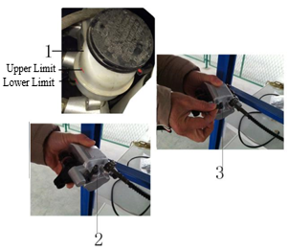
Hydraulic Brake Maintenance
(Please send to the designated shop for maintenance)
Fluid Level:
If the fluid level reaches the lower limit, the hydraulic oil can be added as shown in Fig. 1. Do not continue when the hydraulic oil is added to the upper limit.
Deflating:
As shown in Fig.2, firstly open the cover and loosen the exhaust bolt. Then operate the brake pedal tightly and loosely. Repeat the deflation several times.
Tighten:
After deflating, hold the brake lever, tighten the bolt and close the cover as shown in Fig.3.
Troubleshooting
(I) Power and Brake (Table 1)
Fault | Reason | Approach
Vehicles can’t move | The key switch is turned off or the shift lever is in N (Neutral). | Turn the ignition key to START, move the shift lever to D (Drive) or R (Reverse).
 | Battery without electricity | Recharge the battery.
 | The battery terminal electrode is corroded or loose. | Clean the corrosion site and tighten the link nut.
 | The wire of key switch is loose or damaged. | Connect wires and repair the key switch.
 | The accelerator switch is damaged. | Replace the switch.
 | The air circuit-breaker is not turned on. | Turn on the air circuit-breaker.
 | Drive motor fault | Check the fault area, repair or replace parts
 | The parking brake is not turned off. | Press the button and turn it right to unlock.
Unstable speed | The accelerator is damaged. | Replace the accelerator.
Drive motor noise | The drive motor bearing is worn. | Replace the bearing.
 | The motor is damaged. | Repair damaged parts or replace the motor.
Battery cannot be charged | The charger is damaged. | Check the charger fault, repair or replace parts.
 | Poor contact with charger | Insert the charger plug correctly.
 | The battery is damaged. | Replace the battery.
 | Over discharge of battery | Check or replace the battery.

(Ⅱ) Suspension and Steering Systems (Table 2)
Fault | Reason | Approach
Tire wear is uneven | The tire pressure is too low. | Inflate to the recommended pressure.
Brake deviation | The tire inflation pressure is uneven. | Regulate the inflation pressure.
 | The wheel braking force is uneven. | Regulate the brake shoe.
Insufficient braking force | The brake shoe wears badly. | Replace the brake shoe.
 | The brake oil pipe is leaking and the brake fluid is not enough. | Tighten the tubing joint after exhausting, add the brake fluid.
 | There is oil contamination or water on the brake shoe and the brake disc. | Clean

(III) Electronic Control System (Table 3)
Fault | Reason | Approach
After turning on the key switch, there is no display of the battery indicator and no "click" sound of the contactor. | The key switch is an open circuit. | Repair or replace the switch.
 | The circuit joint is loose or the circuit is disconnected. | Fasten the joint or connect wires.
 | The battery joint is oxidized. | Smooth and clean with the gauze.
 | The control circuit or air circuit breaker is damaged. | Replace
 | The battery polarity is reversed. | Exchange the polarity.
After turning on the key switch, the battery indicator displays and the contactor has "click" sound, but the vehicle does not start. | The accelerator is not returned. | Adjust
 | The drive/reverse switch is damaged. | Inspect, repair, replace.
 | Accelerator fault | Check fault areas, repair or replace parts.
 | Contactor contact fault | Check fault areas, repair or replace parts.
 | Speed controller fault | Check fault areas, repair or replace parts.
 | Drive motor fault | Check fault areas, repair or replace parts.
 | The controller is damped or watered. | Inspect, dry.
The vehicle has a repeated start and stop automatically. | The circuit overcurrent and overheat protection system is not started. | Check whether the parking device has been completely released, whether to carry or climb for a long time. Or to replace the controller.
 | The circuit joint is loose. | Fasten the joint and connect wires.
The vehicle starts briefly but then stops again. | Low battery | Charge the battery.
 | Drive motor fault | Inspect, repair.

Battery Maintenance
This model adopts the sealed battery (free of water).
Caution:
Do not open the electrolyte cover of the sealed battery.
·If the vehicle is not in use for a long time, remove the battery and store it in a cool, ventilated, and dry place after fully charging it.
·If the head of the battery pile is corroded, remove the battery and clean it (rinse with boiling water).

The following figure is the wiring diagram of the 60V dual packs of lead acid batteries.
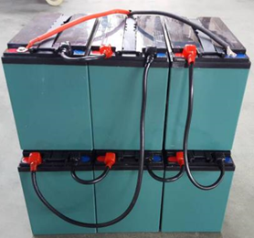
The following figure is the wiring diagram and attentions of the 60V dual battery.
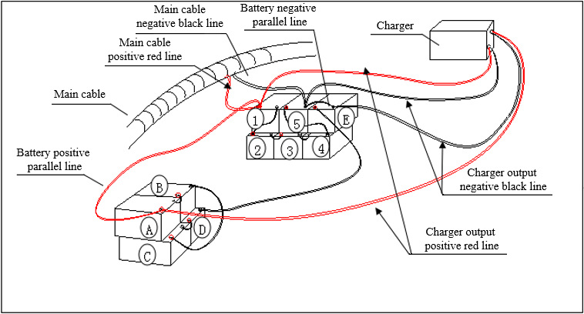
Caution:
To remove the battery, turn off the ignition switch first and then remove the negative pole. To install the battery, the negative pole should be installed after the positive pole. Do not misfit the negative and positive poles.
5.Vehicle Storage
Storage
To store an electric vehicle for a long time, such as in winter, several steps need to be taken to prevent the failure or deterioration of the components. In addition, some maintenance work is required before the storage. Otherwise, once the electric vehicle is used again, it is often forgotten to perform that.
·Replace the gear oil of the rear axle reducer.
·Cover the electric vehicle.
Reuse
·Remove the cover and clean the electric vehicle. If the storage time has exceeded 4 months, the gear oil of the rear axle reducer should be replaced.
·To avoid the battery loss, charge the battery once a month when it is not in use for a long time.
Check all items (See Page 22-25) before driving. To ensure the safety, try to drive the electric vehicle at a low speed for a period of time in an area where the traffic is not heavy.

6.Vehicle Identification
Vehicle Identification Number（VIN Code）
The electric vehicle frame number is located in the lower part of the rear seat, and you can see it when the seat is opened. You need to provide the above number when you want warranty services of repair, replacement and refund.
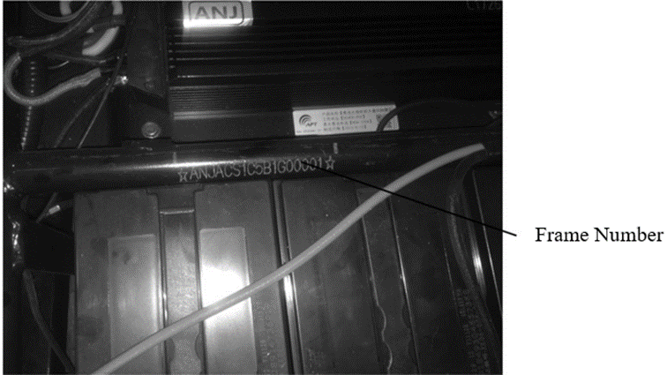
7.Technical Data
Table 4
Item | Product Model | Standard Edition | Economic Edition | Deluxe Edition
Vehicle parameter | Dimension | 2300×1190×1485 | 2300×1190×1485 | 2300×1190×1485
 | Wheel Base | 1715 | 1715 | 1715
 | Track | 1000 | 1000 | 1000
 | Minimum Ground Clearance | 120 | 120 | 120
 | Rated  Maximum Laden Mass | 150 | 150 | 150
 | Curb Mass | 390 | 390 | 450
 | Maximum Speed | 32 | 45 | 45
 | Brake Mode | Hydraulic Disc Brake | Hydraulic Disc Brake | Hydraulic Disc Brake
 | Braking  Operation | Foot Brake | Foot Brake | Foot Brake
 | Tire  Specification | 135/70-R12 | 135/70-R12 | 135/70-R12

Technical Data
Table 5
Item | Product Model | Standard Edition | Economic Edition | Deluxe Edition
Vehicle parameter | Steering Form | Disc | Disc | Disc
 | Rated  Passenger Capacity | 2 People  (including driver) | 2 People  (including driver) | 2 People  (including driver)
 | Parking Mode | Manual (Rear Brake) | Manual (Rear Brake) | Manual (Rear Brake)
Dynamic parameter | Range | 70 | 60 | 100
 | Battery | 72V 45AH | 72V 45AH | 60V 45AH (Dual）
 | Charging  Interval | 8h | 8h | 10h
 | Motor Power | 1.2kw | 2.0kw | 2.8kw/3.0kw

Electrical Schematic
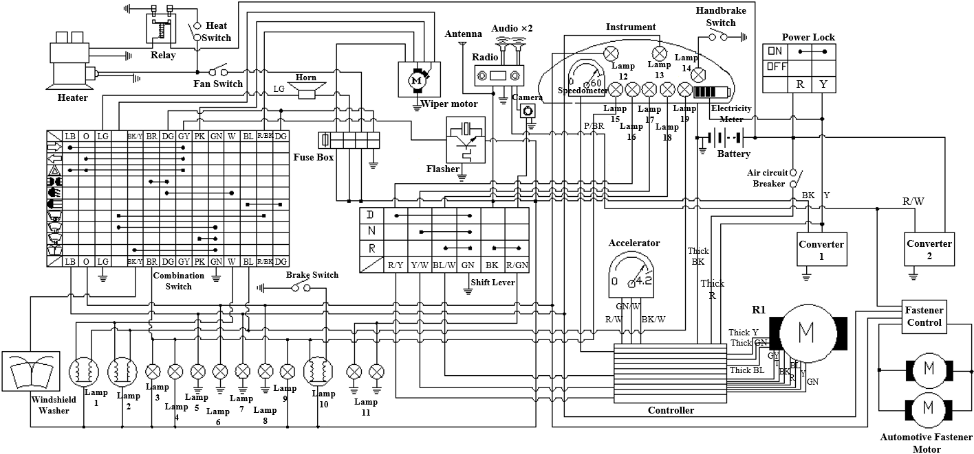

NO. | Lamp | NO. | Lamp
1 | Left Headlamp | 11 | Backup Lamp
2 | Right Headlamp | 12 | Left Turn Indicator Lamp
3 | Front Position Lamp | 13 | Right Turn Indicator Lamp
4 | Front Position Lamp | 14 | Parking Brake Indicator Lamp
5 | Front Right Turn Signal Lamp | 15 | Side Marker Lamp
6 | Front Left Turn Signal Lamp | 16 | Drive Indicator Lamp
7 | Rear Right Turn Signal Lamp | 17 | Neutral Indicator Lamp
8 | Rear Left Turn Signal Lamp | 18 | Reverse Indicator Lamp
9 | License Plate Lamp | 19 | High-beam Indicator Lamp
10 | Taillamp

